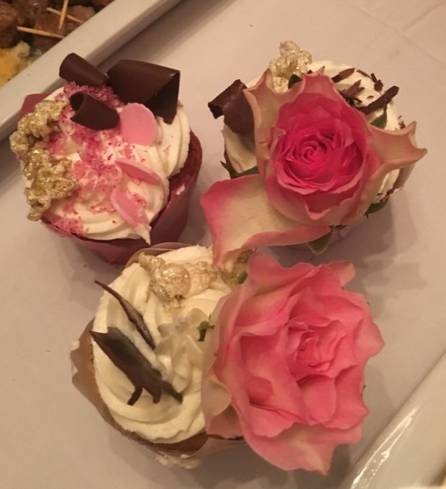
Crazy Easy Cupcakes
Carmen Port Elizabeth

Ingredients
1 Cup sugar
1 Cup margarine or butter (250g)
4 extra large eggs
2 cups of cake flour
1 teaspoon baking powder
¼ teaspoon salt
2 Tablespoons milk
1 teaspoon vanilla

Method
Preheat the oven to 180˚C.
Make sure the butter/margarine is soft. Beat in sugar till light and fluffy. You can use an electric beater or a hand whisk.
Beat in eggs one at a time.
Add dry ingredients. Do not over beat. Rather fold in with a spoon.
Lastly add the milk and vanilla.
To make chocolate cupcakes add 2 Tablespoons cocoa powder and an 1 extra Tablespoon of milk.
Put tablespoons into pans that have been coated with Spray and Cook or use muffin paper cups.
Bake for about 12 minutes or till firm to touch.
Cool, ice and decorate.

